JAVA – 20/05/2024
Java – Programming Language.
Used to Dev the Mobile app, web apps, desktop apps, games, Data base collection etc..
Java as an Object-oriented Programming language.
Java associated with Classes and Objects along with attributes and Methods.
Platforms: Works to different platforms like as Window, IOS, Linux
Why Java Platform independent?
During the compilation the java program converts into byte code. So that byte code we can run the application to any platforms like as Windows, Linux, Mac..
Open Source: Open source like as free.
Why Java program free of cost or open source?
Java Program in which source code is available to the general public free and use/Modification from original design and free of cost
Multithreading: Java Supporting Multithreading. Because of we can access the multi task simultaneously.
More Secure: it’s Provide virtual firewall between the application and the computer.
Writing, compl – Error and debug – after running script
Reusable code
JAVA Install:
For Java installation, we need to JDK file (Java Development kit) is a set of software Tools for developing JAVA Applications.
Toolkit includes Complier for converting JAVA code to bytecode, a collection of class libraries, documentation for integrating API, and the JAVA Runtime Environment for executing the code.

Features or Purpose of Java
The primary objective of Java programming language creation was to make it portable, simple and secure programming language. Apart from this, there are also some excellent features which play an important role in the popularity of this language. The features of Java are also known as Java buzzwords. 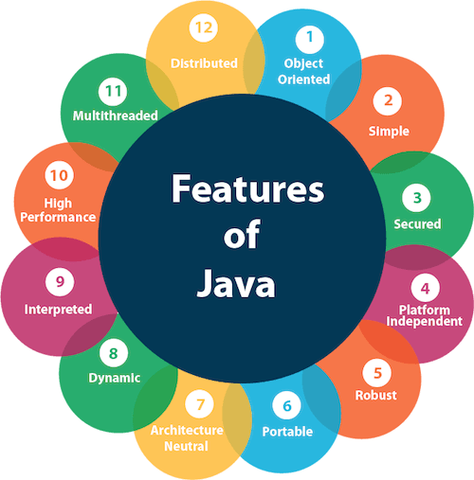
A list of the most important features of the Java language is given below.
- Simple
- Object-Oriented
- Portable – Used for Notepad, Java Complier
- Platform independent
- Secured
- Robust
- Architecture neutral
- Interpreted
- High Performance
- Multithreaded
- Distributed
- Dynamic

Simple
Java is very easy to learn, and its syntax is simple, clean and easy to understand. According to Sun Microsystem, Java language is a simple programming language because:
- Java syntax is based on C++ (so easier for programmers to learn it after C++).
- Java has removed many complicated and rarely-used features, for example, explicit pointers, operator overloading, etc.
- There is no need to remove unreferenced objects because there is an Automatic Garbage Collection in Java.

Object-oriented
Java is an object-oriented programming language. Everything in Java is an object. Object-oriented means we organize our software as a combination of different types of objects that incorporate both data and behavior.
Object-oriented programming (OOPs) is a methodology that simplifies software development and lmaintenance by providing some rules.
Basic concepts of OOPs are:
- Object
- Class
- Inheritance
- Polymorphism
- Abstraction
- Encapsulation

Platform Independent
Works to different platforms like as Window, IOS, Linux
Why Java Platform independent?
During the compilation the java program converts into byte code. So that byte code we can run the application to any platforms like as Windows, Linux, Mac..

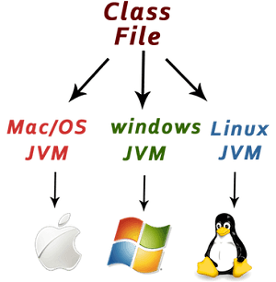

Java is platform independent because it is different from other languages like C, C++, etc. which are compiled into platform specific machines while Java is a write once, run anywhere language. A platform is the hardware or software environment in which a program runs.
There are two types of platforms software-based and hardware-based. Java provides a software-based platform.
The Java platform differs from most other platforms in the sense that it is a software-based platform that runs on top of other hardware-based platforms. It has two components:
- Runtime Environment
- API(Application Programming Interface)
Java code can be executed on multiple platforms, for example, Windows, Linux, Sun Solaris, Mac/OS, etc. Java code is compiled by the compiler and converted into bytecode. This bytecode is a platform-independent code because it can be run on multiple platforms, i.e., Write Once and Run Anywhere (WORA).
Secured
Java is best known for its security. With Java, we can develop virus-free systems. Java is secured because:
- No explicit pointer
- Java Programs run inside a virtual machine sandbox
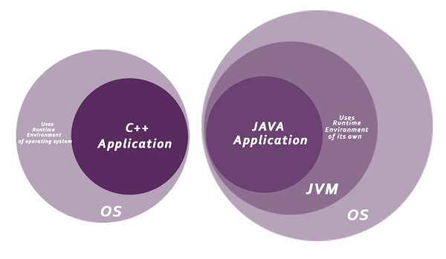
- Classloader: Classloader in Java is a part of the Java Runtime Environment (JRE) which is used to load Java classes into the Java Virtual Machine dynamically. It adds security by separating the package for the classes of the local file system from those that are imported from network sources. – Collection of classes – package
- Bytecode Verifier: It checks the code fragments for illegal code that can violate access rights to objects.
- Security Manager: It determines what resources a class can access such as reading and writing to the local disk.
Java language provides these securities by default. Some security can also be provided by an application developer explicitly through SSL, JAAS, Cryptography, etc.

Robust
The English mining of Robust is strong. Java is robust because:
- It uses strong memory management.
- There is a lack of pointers that avoids security problems.
- Java provides automatic garbage collection which runs on the Java Virtual Machine to get rid of objects which are not being used by a Java application anymore.
- There are exception handling and the type checking mechanism in Java. All these points make Java robust.

Architecture-neutral

Java is architecture neutral because there are no implementation dependent features, for example, the size of primitive types is fixed.
In C programming, int data type occupies 2 bytes of memory for 32-bit architecture and 4 bytes of memory for 64-bit architecture. However, it occupies 4 bytes of memory for both 32 and 64-bit architectures in Java.

Portable
Java is portable because it facilitates you to carry the Java bytecode to any platform. It doesn't require any implementation.
Write once run anywhere. Java code written once machine and we run the any other machines.

High-performance
Java is faster than other traditional interpreted programming languages because Java bytecode is "close" to native code. It is still a little bit slower than a compiled language (e.g., C++). Java is an interpreted language that is why it is slower than compiled languages, e.g., C, C++, etc.

Distributed
Java is distributed because it facilitates users to create distributed applications in Java. RMI(Remote method Invocation) and EJB (Enterprise Java Beans) are used for creating distributed applications. This feature of Java makes us able to access files by calling the methods from any machine on the internet.
RMI - is an API that provides a mechanism to create distributed application in java.
EJB - is a server-side software element that summarizes business logic of an application

Multi-threaded
A thread is like a separate program, executing concurrently. We can write Java programs that deal with many tasks at once by defining multiple threads. The main advantage of multi-threading is that it doesn't occupy memory for each thread. It shares a common memory area. Threads are important for multi-media, Web applications, etc.
Why java Support Multithreaded?
Java Program to Perform Several task simultaneously.

Dynamic
Java is a dynamic language. It supports the dynamic loading of classes. It means classes are loaded on demand. It also supports functions from its native languages, i.e., C and C++.
Java supports dynamic compilation and automatic memory management (garbage collection).
JAVA Technology
JDK – Java Development Kit – if run any application we need JDK have to installed must.
It is a development environment for building applications and components using Java programming. used for developing and executing the java programming language.
Latest Version – JDK 22.0.1 mostly used for JDK 19 windows 11 accept the JDK 19 above version.
JRE– Java Runtime Environment - it is a predefine class files like as library files.
JRE is underlying technology that was communicates b/w java program and OS.
JVM – Java Virtual Machine - it is a enable the computer to run the java program as well as program written in the other languages that are also complied to Java byte code.
Tools:
  - Notepad 2. Net bean 3. Eclipse 4. J Developer-oracle 5. RAD-IBM
Mostly used for Eclipse.
Eclipse version:
Juno • Kepler • Luna • Mars • Neon
Latest Versions: Now Eclipse version name is released year and Month
How to Install The JAVA
- Install the JDK and Set the environment
- Install the Eclipse
Install the JDK: Windows 10 Support JDK 17 and Windows Support JDK 21/22
- Search oracle->Click Download-> Choose the JDK 22/JDK 21
- Choose the windows->click “x64 installer for .exe file-> Install.
JDK setup:
- After install-> go to the program files from D/C driver
- Select the JAVA->JDK 22/21->Bin-> copy the file path
- Search “Environment variables” option from windows
- Choose the advanced -> Click Environment variables
- Under the system variables-> search the Path-> press the double click
- Click new-> Paste the path-> ok->ok->ok
Install the Eclipse:
- Browser -> search eclipse-> choose the eclipse
- In eclipse web page-> Click download
- Choose the Learn more-> Click the other packages
- Choose the “2023-12” package and choose the windows-> download it
Install the Eclipse: Windows support
- Eclipse search window-> Download-> Learn more-> Eclipse ID-> All release /Other package option
- Choose the Release Version-> Click
- Choose the Java Developers-> Click windows
- In Eclipse-> New-> Java Project-> ok -> Finish(Display with JRE & src file)
- Select the src-> Right click new -> Package
- Under the package create the class-> new -> class

How to create Project, Package, Class in Eclipse?
Go the Eclipse-> New-> Java Project-> Enter the Project name -> check the JRE field (JRE Version) and project layout and uncheck the “Working set” and “Modules” filed -> click next-> Finish.
Project name : Should be in Pascal notation.
• Pascal notation : Each word of the first letter should be in capital (ApllicationSystem) • src - Source file
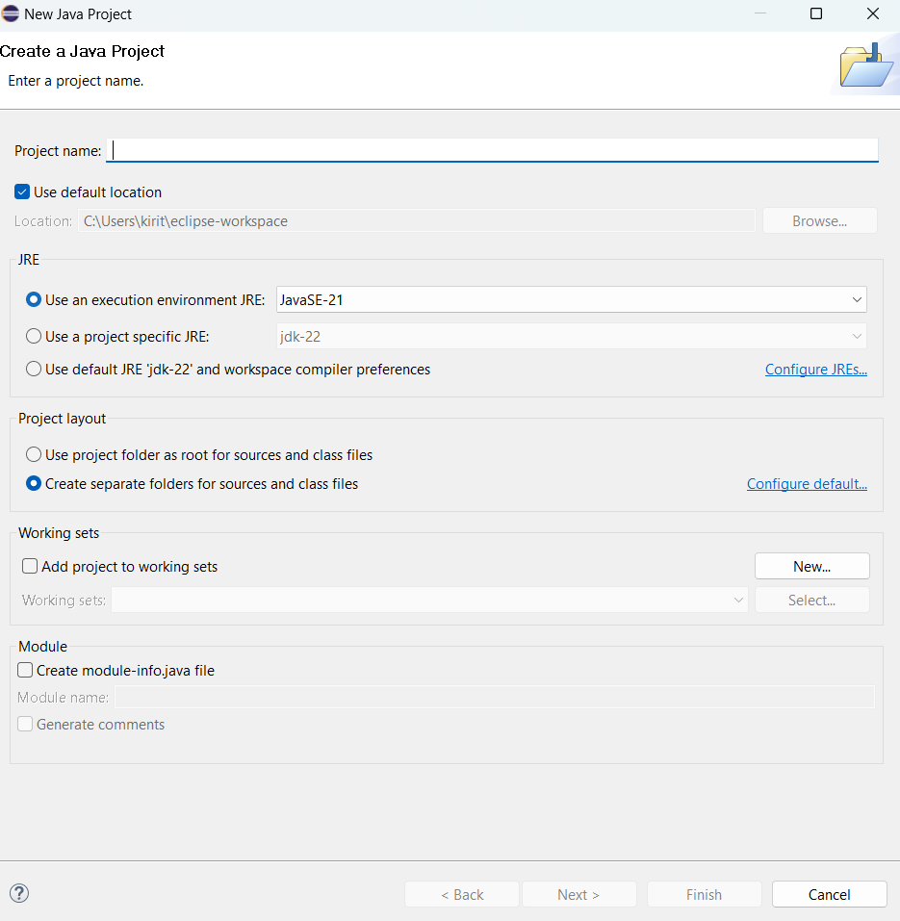

What is meant by Package?
A set of classes and interfaces grouped together are known as Packages in JAVA. The name itself defines that pack (group) of related types such as classes, sub-packages, enumeration, annotations, and interfaces that provide name-space management. Every class is a part of a certain package.

How to create Package?
Go to the Project -> right click new and chose the Package-> Enter the package name -> Click ok.
Package name should be start with com/in/org i.e if company name finish infomats.com
Package name: com.infomats.Javanotes
Package creation: ex, org.cts.scope-All small letters
How to create class?

Java Classes?
A class in Java is a set of objects which shares common characteristics/ behavior and common properties/ attributes. It is a user-defined blueprint or prototype from which objects are created. For example, Student is a class while a particular student named Ravi is an object.

Go to the Package-> Right click new -> class -> enter the class name-> choose the public static option under the method stubs filed and Modifiers: choose the public and none -> Supercalss: Java.lang.Object.
Java.lang - One can find the java. lang package in the lib directory under the Java Runtime Environment installed folder
Class should be start with upper case. Class name: Pascal notation

package com.infomats.javanotes; -> Package

public class Javalearn { - Class

public void Details() {
String Bankname = "XYZ";
System.out.println("Bankname: "+Bankname); - Method
}
public void Account() {
int Accountno = 12345;
System.out.println("Accountno:" +Accountno);
}

public static void main(String[] args) {
// TODO Auto-generated method stub
Javalearn ar = new Javalearn(); - Main Method
ar.Details();
ar.Account();

}

}
FIRST JAVA PROGRAM:
In this section, we will learn how to write the simple program of Java. We can write a simple hello Java program easily after installing the JDK.
To create a simple Java program, you need to create a class that contains the main method. Let's understand the requirement first.
- Install the JDK if you don't have installed it, download the JDK and install it.
- Set path of the jdk/bin directory. http://www.javatpoint.com/how-to-set-path-in-java
- Create the Java program
- Compile and run the Java program

Creating Hello World Example
- class Simple{
- public static void main(String args[]){
- System.out.println("Hello Java");
- }
- }
- Save the above file as Simple.java.
To compile: | javac Simple.java
To execute: | java Simple (Run: Run -> Run as-> Java Application
Output:
Hello Java
Compilation Flow:
When we compile Java program using javac tool, the Java compiler converts the source code into byte code.
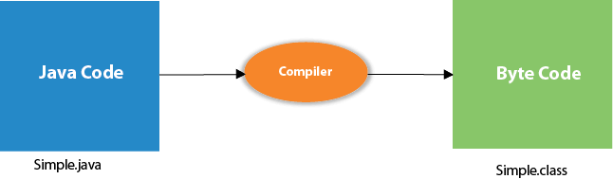

Parameters used in First Java Program
Let's see what is the meaning of class, public, static, void, main, String[], System.out.println().
- class keyword is used to declare a class in Java.
- public keyword is an access modifier that represents visibility. It means it is visible to all.
- static is a keyword. If we declare any method as static, it is known as the static method. The core advantage of the static method is that there is no need to create an object to invoke the static method. The main() method is executed by the JVM, so it doesn't require creating an object to invoke the main() method. So, it saves memory.
- void is the return type of the method. It means it doesn't return any value.
- main represents the starting point of the program.
- String[] args or String args[] is used for command line argument. We will discuss it in coming section.
- System.out.println() is used to print statement. Here, System is a class, out is an object of the PrintStream class, println() is a method of the PrintStream class. We will discuss the internal working of System.out.println() statement in the coming section. – Output print command.
- Print – Output statement printed continue
- Println – Output statements printed new line
- Printf – Output statements printed Files format

To compile and run the above program, go to your current directory first; my current directory is c:\new. Write here:
To compile: | javac Simple.java
To execute: | java Simple

In how many ways we can write a Java program?
There are many ways to write a Java program. The modifications that can be done in a Java program are given below:
1) By changing the sequence of the modifiers, method prototype is not changed in Java.
Let's see the simple code of the main method.
- static public void main(String args[])
2) The subscript notation in the Java array can be used after type, before the variable or after the variable.
Let's see the different codes to write the main method.
- public static void main(String[] args)
- public static void main(String []args)
- public static void main(String args[])
3) You can provide var-args support to the main() method by passing 3 ellipses (dots)
Let's see the simple code of using var-args in the main() method. We will learn about var-args later in the Java New Features chapter.
- public static void main(String... args)
4) Having a semicolon at the end of class is optional in Java.
Let's see the simple code.
- class A{
- static public void main(String... args){
- System.out.println("hello java4");
- }
- };

Valid Java main() method signature
- public static void main(String[] args)
- public static void main(String []args)
- public static void main(String args[])
- public static void main(String... args)
- static public void main(String[] args)
- public static final void main(String[] args)
- final public static void main(String[] args)
- final strictfp public static void main(String[] args)

Invalid Java main() method signature
- public void main(String[] args)
- static void main(String[] args)
- public void static main(String[] args)
- abstract public static void main(String[] args)

Print Text
System.out.println("Hello World!");
You can add as many println() methods as you want. Note that it will add a new line for each method:
System.out.println("Hello World!");
System.out.println("I am learning Java.");
System.out.println("It is awesome!");

Double Quots
When you are working with text, it must be wrapped inside double quotations marks "".
If you forget the double quotes, an error occurs:
System.out.println("This sentence will work!");
System.out.println(This sentence will produce an error);

The Print() Method
There is also a print() method, which is similar to println().
The only difference is that it does not insert a new line at the end of the output:

Example
System.out.print("Hello World! ");
System.out.print("I will print on the same line.");
Note that we add an extra space (after "Hello World!" in the example above), for better readability.
In this tutorial, we will only use println() as it makes it easier to read the output of code.
Print Numbers
You can also use the println() method to print numbers.
However, unlike text, we don't put numbers inside double quotes:

ExampleGet your own Java Server
System.out.println(3);
System.out.println(358);
System.out.println(50000);
You can also perform mathematical calculations inside the println() method:
System.out.println(3 + 3);
System.out.println(2 * 5);

Java Comments
Comments can be used to explain Java code, and to make it more readable. It can also be used to prevent execution when testing alternative code.

Single-line Comments
Single-line comments start with two forward slashes (//).
Any text between // and the end of the line is ignored by Java (will not be executed).
This example uses a single-line comment before a line of code:

ExampleGet your own Java Server
// This is a comment
System.out.println("Hello World");
This example uses a single-line comment at the end of a line of code:
System.out.println("Hello World"); // This is a comment

Java Multi-line Comments
Multi-line comments start with /* and ends with */.
Any text between /* and */ will be ignored by Java.
This example uses a multi-line comment (a comment block) to explain the code:
/* The code below will print the words Hello World
to the screen, and it is amazing */
System.out.println("Hello World");

Single or multi-line comments?
It is up to you which you want to use. Normally, we use // for short comments, and /* */ for longer.
JAVA Variables
Variables are containers for storing the data.
Variables Types:
Local Variable, Instance Variable, Static Variable

Local Variable: Variables Declared inside a method
Instance Variables: Variables declared inside a class

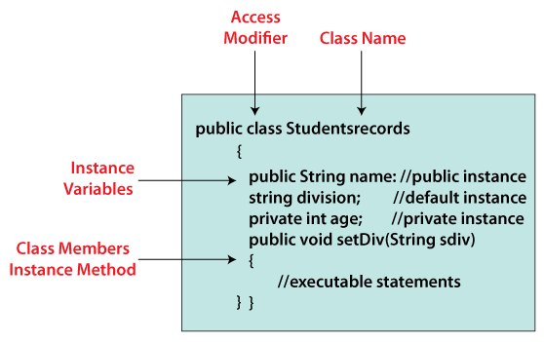

Static Variables: Variables declared with static keyword
A static variable possesses the property of preserving its actual value even after it is out of its scope

Variables:
- String - stores text, such as "Hello". String values are surrounded by double quotes
- int - stores integers (whole numbers), without decimals, such as 123 or -123
- float - stores floating point numbers, with decimals, such as 19.99 or -19.99
- char - stores single characters, such as 'a' or 'B'. Char values are surrounded by single quotes
- boolean - stores values with two states: true or false

Declaring (Creating) Variables
Syntax: type variableName = value;
The equal sign is used to assign values to the variable.

Example
Create a variable called name of type String and assign it the value "John":
String name = "John";
System.out.println(name);

Example
Create a variable called myNum of type int and assign it the value 15:
int myNum = 15;
System.out.println(myNum)
You can also declare a variable without assigning the value, and assign the value later:

Example
int myNum;
myNum = 15;
System.out.println(myNum);

ExampleGet your own Java Server
String name = "John";
System.out.println("Hello: " + name);
The println() method is often used to display variables.
To combine both text and a variable, use the + character:

You can also use the + character to add a variable to another variable:

Example
String firstName = "John ";
String lastName = "Doe";
String fullName = firstName + lastName;
System.out.println(fullName);

Java Declare Multiple Variables

To declare more than one variable of the same type, you can use a comma-separated list:
Example:
int x = 5, y = 6, z = 50;
System.out.println(x + y + z);

One Value to Multiple Variables
You can also assign the same value to multiple variables in one line:
Example:
int x, y, z;
x = y = z = 50;
System.out.println(x + y + z);

Identifiers
All Java variables must be identified with unique names.
These unique names are called identifiers.
Identifiers can be short names (like x and y) or more descriptive names (age, sum, totalVolume).
Note: It is recommended to use descriptive names in order to create understandable and maintainable code:

Example
// Good
int minutesPerHour = 60;

// OK, but not so easy to understand what m actually is
int m = 60;

Java Data Types
a variable in Java must be a specified data type
Data types are divided into two groups:
- Primitive data types - includes byte, short, int, l ong, float, double, boolean and char
- Non-primitive data types - such as String, Arrays and Classes etc…

Primitive Data Types
A primitive data type specifies the size and type of variable values, and it has no additional methods.
Data Type | Size | Description
Byte | 1 byte | Stores whole numbers from -128 to 127
Short | 2 bytes | Stores whole numbers from -32,768 to 32,767
Int | 4 bytes | Stores whole numbers from -2,147,483,648 to 2,147,483,647
Long | 8 bytes | Stores whole numbers from -9,223,372,036,854,775,808 to 9,223,372,036,854,775,807
Float | 4 bytes | Stores fractional numbers. Sufficient for storing 6 to 7 decimal digits
Double | 8 bytes | Stores fractional numbers. Sufficient for storing 15 decimal digits
Boolean | 1 bit | Stores true or false values
Char | 2 bytes | Stores a single character/letter or ASCII values
JAVA Numbers
Primitive numbers types of two groups:
Integer Data types: Stores Whole numbers +ve/-ve.
Types: int, long, byte, short
Floating Data types: Representing the numbers with fractional or decimal format.
Types: float, double.
Integer Types:
Byte: It also one of the data type, it can be store whole numbers. Byte also used for instead of int.
byte myNum = 100;
System.out.println(myNum);

Short: It also stores the whole value
short myNum = 5000;
System.out.println(myNum);
INT: int data type mostly used data, when/while creating variable with a numeric value. Store whole value
Int myNum = 50;
System.out.println(myNum);
Long: it also store the whole numbers and it was used for when int is not enough for store the whole value and end of the value should be add “L” – not case sensitive we can use Upper and lower case.
Floating Point types: Representing the numbers with fractional or decimal format.
Types: Float and Double, stores the fractional values.
Should be add f end of the value in float type.
Example:
double myNum = 19.99d;
System.out.println(myNum);
float myNum = 5.75f;
System.out.println(myNum);

Boolean Types:
It is also one of the data types with two possible ways for represent the truth conditions and found the logic control: it was expression returns the Boolean value. Mostly used for conditional testing.
Like as Yes/No, On/Off and True/False.
Example:
boolean isJavaFun = true;
boolean isFishTasty = false;
System.out.println(isJavaFun); // Outputs true
System.out.println(isFishTasty);
Characters
The Char also one data type, it also used to store a single character. The characters should be surrender in single quotes ‘s’.
Example:
Char number = ‘s’;
System.out.println(number);
String: non Primitive Types
The string also type of data and it was store the sequence of character (Text) and The text must be surrender in double quotes “Text”.
Example:
String Name =”Text”;
System.out.println(“Name”);
Java Type casting:
Assign a value of one primitive data type to another type.
Widening casting: converted automatically – Smaller data type to larger type size
byte -> short -> char -> int -> long -> float -> double
Narrowing casting: Converted manually – Higher data type to smaller type size.
double -> float -> long -> int -> char -> short -> byte
Non_primitive Types - it was called as a reference type, referred to object .
JAVA Operators:
It was comparison, Operators are used to compare the two values.
Example int c=a+b; + Operator.
Java have multi types of Operators:
  - Arithmetic operator
  - Assignment operator
  - Comparison operator
  - Logical Operator
  - Bitwise Operator
  - Unary Operator
  - Relational Operator
  - Instance of Operator
  - Shift Operator
Arithmetic Operator: Used for simple Arithmetic operator on primitive data types.

Add + , Sub -, Multiplication *, Division /, Modulo %.
public static void main (String[] args) {

// Arithmetic operators
int a = 10;
int b = 3;

System.out.println("a + b = " + (a + b));

Unary Operators: it was used to only one operand. Used to increment, decrement or negate value.
Unary minus: used for Negating the value. -
Unary plus: Indicate the positive value. It perform automatic conversion to int when the types of operand id char,short byte. Called unary numeric. +
Increment Operator: used for increment the value by 1 ++. It have post increment operator a+ and pre increment operator +a.
Decrement Operator: used for decrement the value by 1. Post decrement operator a- and pre operator -a.

System.out.println("Postincrement : " + (a++));
System.out.println("Preincrement : " + (++a));

Assignment Operator: = Assignment operator is used to assign a value to any variable, value given on the right-hand side of the operator is assigned to the variable on the left, right-hand side value must be declared before using it or should be a constant.
A=a+5 converts to a+=5
+= , -=. *=, /=, %=,
System.out.println("f += 3: " + (f += 3));
System.out.println("f -= 2: " + (f -= 2));

Relational Operators or Comparsion: These Operators check for relations like Equality, Greater than and Less than.
They return Boolean results after the comparison and extensively used in looping statements as well as condition if -else statements.
Varibale relational_opertaor value

- ==, Equal to returns true if the left-hand side is equal to the right-hand side.
- !=, Not Equal to returns true if the left-hand side is not equal to the right-hand side.
- <, less than: returns true if the left-hand side is less than the right-hand side.
- <=, less than or equal to returns true if the left-hand side is less than or equal to the right-hand side.
- >, Greater than: returns true if the left-hand side is greater than the right-hand side.
- >=, Greater than or equal to returns true if the left-hand side is greater than or equal to the right-hand side.

- System.out.println("a > b: " + (a > b));
- System.out.println("a < b: " + (a < b));

Logical Operators

Perform the Logical AND and logic OR operations.
Logical operator: used for inverting the Boolean value.

- &&, Logical AND: returns true when both conditions are true.
- ||, Logical OR: returns true if at least one condition is true.
- !, Logical NOT: returns true when a condition is false and vice-versa
- System.out.println("x && y: " + (x && y));
- System.out.println("x || y: " + (x || y));
- System.out.println("!x: " + (!x));

Return Type
In Java, every method is declared with a return type such as int, float, double, string, etc. These return types required a return statement at the end of the method. A return keyword is used for returning the resulted value. The void return type doesn't require any return statement.

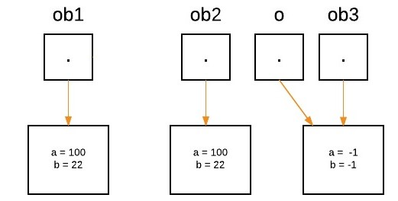

Syntax: return rentvalue;
Example:
package com.infomats.javanotes;

public class Returntype {
static int a=6,b=5;
static int c;
public int Return() {
c=a+b;
System.out.println("c:" +c);
return c;

}
public static void main(String[] args) {
Returntype re = new Returntype();
re.Return();
int Result = c+a;
System.out.println("Total:" +Result);

}
}

Access Modifier:
in Java, Access modifiers help to restrict the scope of a class, constructor, variable, method, or data member.

Types of Access Modifiers in Java
There are four types of access modifiers available in Java:
- Public
- Private
- Protected
- Default

Access Modifier | within class | within package | outside package by subclass only | outside package
Private | Y | N | N | N
Default | Y | Y | N | N
Protected | Y | Y | Y | N
Public | Y | Y | Y | Y

Public Access Modifier : Using keyword public
- The public access modifier is accessible everywhere. It has the widest scope among all other modifiers.
- The access level of a public modifier is everywhere. It can be accessed from within the class, outside the class, within the package and outside the package.

Create one new package, import the Previous package with class if need hole class add * or else add particular class only

Syntax: import Previouspackagename.*;
Import.previouspackagename.classname;

Example:
package Accesspublic;
import com.infomats.javanotes.*;
public class Accessmod {

public static void main(String[] args) {
Studentdetails sd =new Studentdetails ();
Returntype ty = new Returntype();
sd.Totalmarks();
sd.Averagemarks();
ty.Return();
}

}

Private Access Modifier: Using keyword ‘private’.
- The private modifier specifies that the member can only be accessed in its own class.
- The Private access modifier is accessible only within the class.

Scanner:
The Scanner class is used to get user input, and it is found in the java.util package.

To use the Scanner class, create an object of the class and use any of the available methods found in the Scanner class documentation. In our example, we will use the nextLine() method, which is used to read Strings:

Finish the program->Run-> Enter input values(should be displayed in green colour-> then get the output

Java Scanner Input Types
Scanner class helps to take the standard input stream in Java. So, we need some methods to extract data from the stream. Methods used for extracting data are mentioned below:
Method | Description
nextBoolean() | Used for reading Boolean value
nextByte() | Used for reading Byte value
nextDouble() | Used for reading Double value
nextFloat() | Used for reading Float value
nextInt() | Used for reading Int value
nextLine() | Used for reading Line value
nextLong() | Used for reading Long value
nextShort() | Used for reading Short value

Condition:
The Java if statement is used to test the condition. It checks boolean condition: true or false. There /are various types of if statement in Java.

- if statement
- if-else statement
- if-else-if ladder
- nested if statement
Java if statement:
The Java if statement tests the condition. It executes the if block if condition is true.
Syntax:
- if(condition){
- //code to be executed
- }
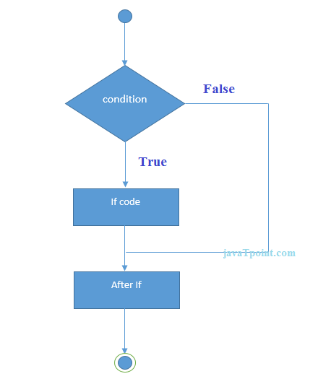

Java if-else Statement
The Java if-else statement also tests the condition. It executes the if block if condition is true otherwise else block is executed.
Syntax:
- if(condition){
- //code if condition is true
- }else{
- //code if condition is false
- }
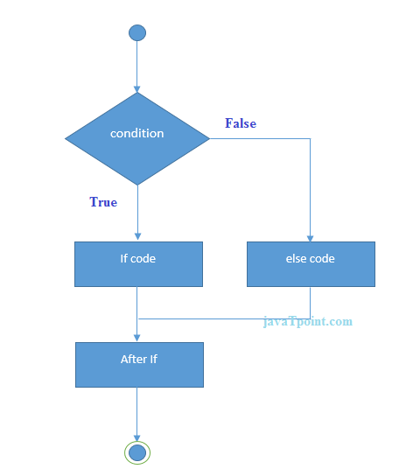

Java if-else-if ladder Statement
The if-else-if ladder statement executes one condition from multiple statements.

Syntax:
- if(condition1){
- //code to be executed if condition1 is true
- }else if(condition2){
- //code to be executed if condition2 is true
- }
- else if(condition3){
- //code to be executed if condition3 is true
- }
- ...
- else{
- //code to be executed if all the conditions are false
- }

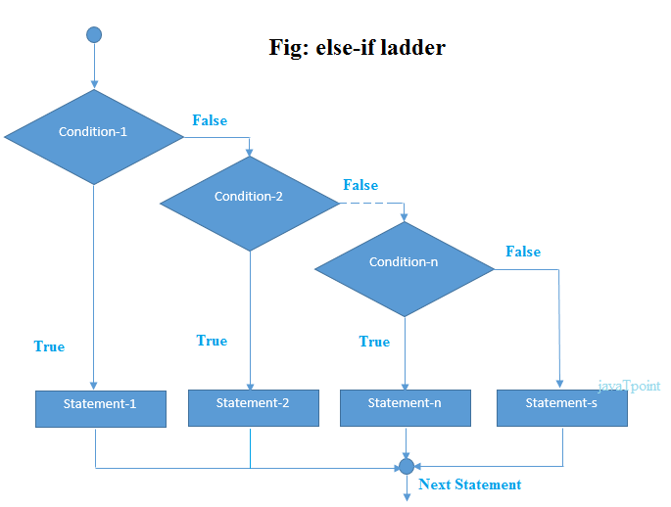

Java Nested if statement
The nested if statement represents the if block within another if block. Here, the inner if block condition executes only when outer if block condition is true.

Syntax:
- if(condition){
- //code to be executed
- if(condition){
- //code to be executed
- }
- }

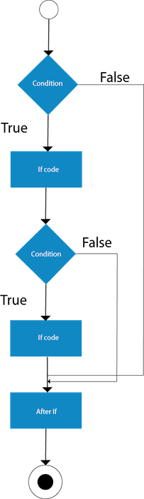

Switch case:
The switch statement in Java is a multi-way branch statement. In simple words, the Java switch statement executes one statement from multiple conditions.
It is like an if-else-if ladder statement. It provides an easy way to dispatch execution to different parts of code based on the value of the expression. The expression can be a byte, short, char, or int primitive data type. It tests the equality of variables against multiple values.

Syntax
switch(expression)
{
case value1 :
// Statements
break; // break is optional
case value2 :
// Statements
break; // break is optional
....
....
....
default :
// default Statement
}

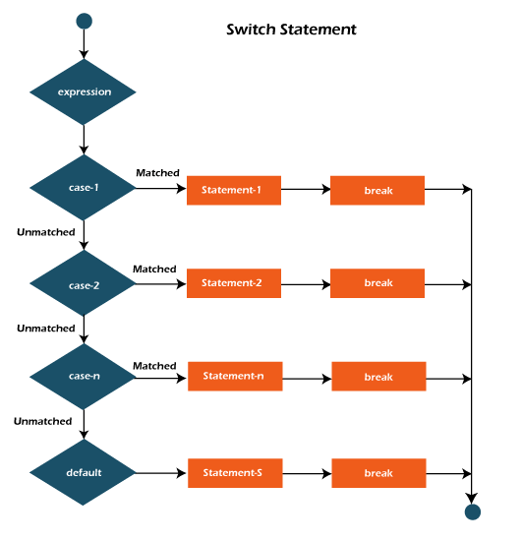

Loop:
Looping in programming languages is a feature which facilitates the execution of a set of instructions/functions repeatedly while some condition evaluates to true. Java provides three ways for executing the loops. While all the ways provide similar basic functionality, they differ in their syntax and condition checking time.

while loop: A while loop is a control flow statement that allows code to be executed repeatedly based on a given Boolean condition. The while loop can be thought of as a repeating if statement.

Syntax:
while (boolean condition)
{
loop statements...
}
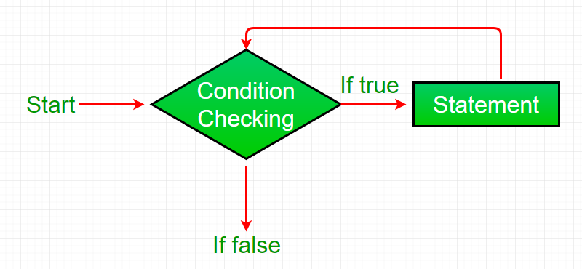

- While loop starts with the checking of Boolean condition. If it evaluated to true, then the loop body statements are executed otherwise first statement following the loop is executed. For this reason it is also called Entry control loop
- Once the condition is evaluated to true, the statements in the loop body are executed. Normally the statements contain an update value for the variable being processed for the next iteration.
- When the condition becomes false, the loop terminates which marks the end of its life cycle.

For Loop : for loop provides a concise way of writing the loop structure. Unlike a while loop, a for statement consumes the initialization, condition and increment/decrement in one line thereby providing a shorter, easy to debug structure of looping.

Syntax:
for (initialization condition; testing condition;increment/decrement)
{
statement(s)
}

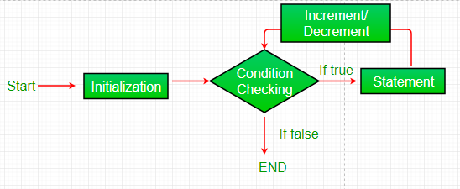

- Initialization condition: Here, we initialize the variable in use. It marks the start of a for loop. An already declared variable can be used or a variable can be declared, local to loop only.
- Testing Condition: It is used for testing the exit condition for a loop. It must return a boolean value. It is also an Entry Control Loop as the condition is checked prior to the execution of the loop statements.
- Statement execution: Once the condition is evaluated to true, the statements in the loop body are executed.
- Increment/ Decrement: It is used for updating the variable for next iteration.
- Loop termination:When the condition becomes false, the loop terminates marking the end of its life cycle.

do while: do while loop is similar to while loop with only difference that it checks for condition after executing the statements, and therefore is an example of Exit Control Loop.

Syntax:
do
{
statements..
}
while (condition);
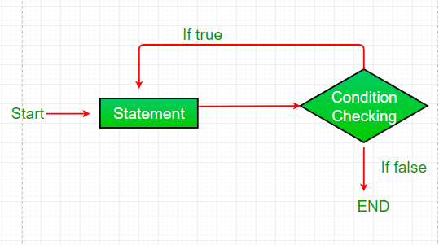

- do while loop starts with the execution of the statement(s). There is no checking of any condition for the first time.
- After the execution of the statements, and update of the variable value, the condition is checked for true or false value. If it is evaluated to true, next iteration of loop starts.
- When the condition becomes false, the loop terminates which marks the end of its life cycle.
- It is important to note that the do-while loop will execute its statements atleast once before any condition is checked, and therefore is an example of exit control loop.

Nested for Loop & Nested While Loop

JAVA ARRAYS:
Arrays are used to store multiple values in a single variable, instead of declaring separate variables for each value.
To declare an array, define the variable type with square brackets:
String[] cars;
We have now declared a variable that holds an array of strings. To insert values to it, you can place the values in a comma-separated listcurly braces:
String[] cars = {"Volvo", "BMW", "Ford", "Mazda"};
To create an array of integers, you could write:
int[] myNum = {10, 20, 30, 40};
Note:
- Array indices always start from 0. That is, the first element of an array is at index 0.
- If the size of an array is n, then the last element of the array will be at index n-1.
Synatax:
Datatypes[] object = {values};
JAVA STATIC
The static keyword in Java is mainly used for memory management. The static keyword in Java is used to share the same variable or method of a given class. The users can apply static keywords with variables, methods, blocks, and nested classes. The static keyword belongs to the class than an instance of the class. The static keyword is used for a constant variable or a method that is the same for every instance of a class.
The static keyword is a non-access modifier in Java that is applicable for the following:
- Blocks
- Variables
- Methods
- Classes

Characteristics of static keyword:
Here are some characteristics of the static keyword in Java:

- Shared memory allocation: Static variables and methods are allocated memory space only once during the execution of the program. This memory space is shared among all instances of the class, which makes static members useful for maintaining global state or shared functionality.
- Accessible without object instantiation: Static members can be accessed without the need to create an instance of the class. This makes them useful for providing utility functions and constants that can be used across the entire program.
- Associated with class, not objects: Static members are associated with the class, not with individual objects. This means that changes to a static member are reflected in all instances of the class, and that you can access static members using the class name rather than an object reference.
- Cannot access non-static members: Static methods and variables cannot access non-static members of a class, as they are not associated with any particular instance of the class.
- Can be overloaded, but not overridden: Static methods can be overloaded, which means that you can define multiple methods with the same name but different parameters. However, they cannot be overridden, as they are associated with the class rather than with a particular instance of the class.

String:
The string is a sequence of characters. In Java, objects of String are immutable which means a constant and cannot be changed once created.

Ways of Creating a String
There are two ways to create a string in Java:
- String Literal
- Using new Keyword
Syntax:
<String_Type> <string_variable> = "<sequence_of_string>";

1. String literal
To make Java more memory efficient (because no new objects are created if it exists already in the string constant pool).
Example:
String demoString = “GeeksforGeeks”;

2. Using new keyword
- String s = new String(“Welcome”);
- In such a case, JVM will create a new string object in normal (non-pool) heap memory and the literal “Welcome” will be placed in the string constant pool. The variable s will refer to the object in the heap (non-pool)
Example:
String demoString = new String (“GeeksforGeeks”);

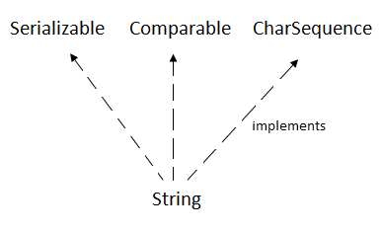

CharSequence Interface The CharSequence interface is used to represent the sequence of characters. String, StringBuffer and StringBuilder classes implement it. It means, we can create strings in Java by using these three classes.

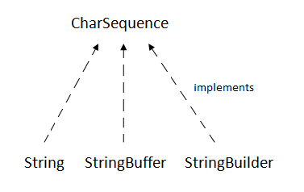 The Java String is immutable which means it cannot be changed. Whenever we change any string, a new instance is created. For mutable strings, you can use StringBuffer and StringBuilder classes.
We will discuss immutable string later. Let's first understand what String in Java is and how to create the String object.

All String Methods

The String class has a set of built-in methods that you can use on strings.
No. | Method | Description
1 | char charAt(int index) | It returns char value for the particular index
2 | int length() | It returns string length
3 | static String format(String format, Object... args) | It returns a formatted string.
4 | static String format(Locale l, String format, Object... args) | It returns formatted string with given locale.
5 | String substring(int beginIndex) | It returns substring for given begin index.
6 | String substring(int beginIndex, int endIndex) | It returns substring for given begin index and end index.
7 | boolean contains(CharSequence s) | It returns true or false after matching the sequence of char value.
8 | static String join(CharSequence delimiter, CharSequence... elements) | It returns a joined string.
9 | static String join(CharSequence delimiter, Iterable<? extends CharSequence> elements) | It returns a joined string.
10 | boolean equals(Object another) | It checks the equality of string with the given object.
11 | boolean isEmpty() | It checks if string is empty.
12 | String concat(String str) | It concatenates the specified string.
13 | String replace(char old, char new) | It replaces all occurrences of the specified char value.
14 | String replace(CharSequence old, CharSequence new) | It replaces all occurrences of the specified CharSequence.
15 | static String equalsIgnoreCase(String another) | It compares another string. It doesn't check case.
16 | String[] split(String regex) | It returns a split string matching regex.
17 | String[] split(String regex, int limit) | It returns a split string matching regex and limit.
18 | String intern() | It returns an interned string.
19 | int indexOf(int ch) | It returns the specified char value index.
20 | int indexOf(int ch, int fromIndex) | It returns the specified char value index starting with given index.
21 | int indexOf(String substring) | It returns the specified substring index.
22 | int indexOf(String substring, int fromIndex) | It returns the specified substring index starting with given index.
23 | String toLowerCase() | It returns a string in lowercase.
24 | String toLowerCase(Locale l) | It returns a string in lowercase using specified locale.
25 | String toUpperCase() | It returns a string in uppercase.
26 | String toUpperCase(Locale l) | It returns a string in uppercase using specified locale.
27 | String trim() | It removes beginning and ending spaces of this string.
28 | static String valueOf(int value) | It converts given type into string. It is an overloaded method.

String Buffer and String Builder

String Buffer
String Builder

OOPS: Object oriented Programming system

Object means a real-world entity such as a pen, chair, table, computer, watch, etc. Object-Oriented Programming is a methodology or paradigm to design a program using classes and objects. It simplifies software development and maintenance by providing some concepts:
- Object
- Class
- Inheritance
- Polymorphism
- Abstraction
- Encapsulation

Inheritance
Inheritance in Java is a mechanism in which one object acquires all the properties and behaviors of a parent object. It is an important part of OOPs (Object Oriented programming system).
The idea behind inheritance in Java is that you can create new classes that are built upon existing classes. When you inherit from an existing class, you can reuse methods and fields of the parent class. Moreover, you can add new methods and fields in your current class also.
Inheritance represents the IS-A relationship which is also known as a parent-child relationship.
- For Method Overriding (so runtime polymorphism can be achieved).
- For Code Reusability.

Terms used in Inheritance
- Class: A class is a group of objects which have common properties. It is a template or blueprint from which objects are created.
- Sub Class/Child Class: Subclass is a class which inherits the other class. It is also called a derived class, extended class, or child class.
- Super Class/Parent Class: Superclass is the class from where a subclass inherits the features. It is also called a base class or a parent class.
- Reusability: As the name specifies, reusability is a mechanism which facilitates you to reuse the fields and methods of the existing class when you create a new class. You can use the same fields and methods already defined in the previous class.
Syntax:
class Subclass-name extends Superclass-name
{
//methods and fields
}
The extends keyword indicates that you are making a new class that derives from an existing class. The meaning of "extends" is to increase the functionality.
Child class◊ Sub class
Parent class◊ Super class
Types:
1. Single Inheritance
2. Multilevel Inheritance
3. Multiple Inheritances
4. Hybrid Inheritance
5. Hierarchical Inheritance
Single Inheritance: One parent class directly support into the one child class using Extends Keyword
Child Class <------------- Parent class
Multilevel Inheritance: One Child class More than one parent class
Child class ←------------------ Parent class ←-------------- Grand parent

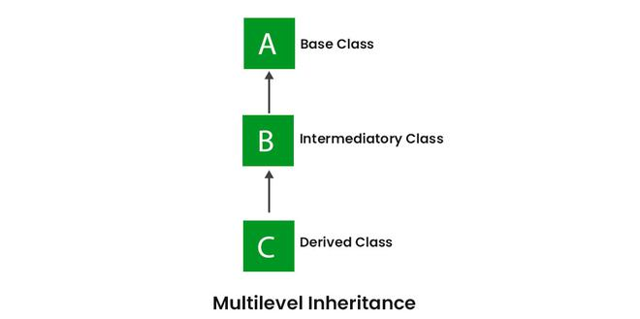
Multiple Inheritance
Parent class-----→ Child class----------→ Parent class
More than one parent class parallelly support into one child class but it won't support in java because 1. Priority problem 2. Compilation error/syntax error (i.e) if both parent class having same method name it will get priority problem so it doesn;t work in java.
Hybrid Inheritance: It is a combination of single and multiple inheritance.
It is a mix of two or more of the above types of inheritance. Since Java doesn’t support multiple inheritances with classes, hybrid inheritance involving multiple inheritance is also not possible with classes. In Java, we can achieve hybrid inheritance only through Interfaces if we want to involve multiple inheritance to implement Hybrid inheritance.
However, it is important to note that Hybrid inheritance does not necessarily require the use of Multiple Inheritance exclusively. It can be achieved through a combination of Multilevel Inheritance and Hierarchical Inheritance with classes, Hierarchical and Single Inheritance with classes. Therefore, it is indeed possible to implement Hybrid inheritance using classes alone, without relying on multiple inheritance type.
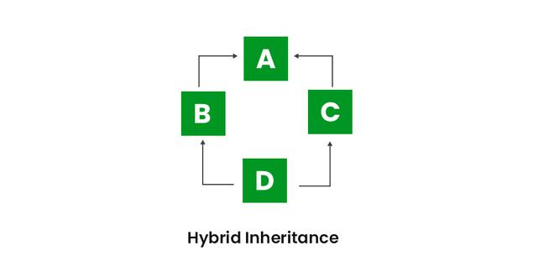
  - Parent class , B- Mother class, C- Father class and D- Child class

Polymorphism:
The word polymorphism means having many forms. In simple words, we can define Java Polymorphism as the ability of a message to be displayed in more than one form. In this article, we will learn what is polymorphism and it’s type.
Real-life Illustration of Polymorphism in Java: A person at the same time can have different characteristics. Like a man at the same time is a father, a husband, and an employee. So the same person possesses different behaviors in different situations. This is called polymorphism.

What is Polymorphism in Java?
Polymorphism is considered one of the important features of Object-Oriented Programming. Polymorphism allows us to perform a single action in different ways. In other words, polymorphism allows you to define one interface and have multiple implementations. The word “poly” means many and “morphs” means forms, So it means many forms.

Types:
Overloading
Overriding

Method Overloading
When there are multiple functions with the same name but different parameters then these functions are said to be overloaded. Functions can be overloaded by changes in the number of arguments or/and a change in the type of arguments.

Method Overriding:
It is also known as Dynamic Method Dispatch. It is a process in which a function call to the overridden method is resolved at Runtime. This type of polymorphism is achieved by Method Overriding. Method overriding, on the other hand, occurs when a derived class has a definition for one of the member functions of the base class. That base function is said to be overridden.

Abstract
In Java, abstract class is declared with the abstract keyword. It may have both abstract and non-abstract methods(methods with bodies). An abstract is a Java modifier applicable for classes and methods in Java but not for Variables. In this article, we will learn the use of abstract classes in Java.

What is Abstract Class in Java?
Java abstract class is a class that can not be initiated by itself, it needs to be subclassed by another class to use its properties. An abstract class is declared using the “abstract” keyword in its class definition.

In Java, the following some important observations about abstract classes are as follows:
- An instance of an abstract class can not be created.
- Constructors are allowed.
- We can have an abstract class without any abstract method.
- There can be a final method in abstract class but any abstract method in class(abstract class) can not be declared as final or in simpler terms final method can not be abstract itself as it will yield an error: “Illegal combination of modifiers: abstract and final”
- We can define static methods in an abstract class
- We can use the abstract keyword for declaring top-level classes (Outer class) as well as inner classes as abstract
- If a class contains at least one abstract method then compulsory should declare a class as abstract
- If the Child class is unable to provide implementation to all abstract methods of the Parent class then we should declare that Child class as abstract so that the next level Child class should provide implementation to the remaining abstract method

Collection:
The Collection in Java is a framework that provides an architecture to store and manipulate the group of objects.
Java Collections can achieve all the operations that you perform on a data such as searching, sorting, insertion, manipulation, and deletion.
Java Collection means a single unit of objects. Java Collection framework provides many interfaces (Set, List, Queue, Deque) and classes (ArrayList, Vector, LinkedList, PriorityQueue, HashSet, LinkedHashSet, TreeSet).
What is a framework in Java
- It provides readymade architecture.
- It represents a set of classes and interfaces.
- It is optional.

What is Collection framework
The Collection framework represents a unified architecture for storing and manipulating a group of objects. It has:
- Interfaces and its implementations, i.e., classes
- Algorithm
Hierarchy of Collection Framework
Let us see the hierarchy of Collection framework. The java.util package contains all the classes and interfaces for the Collection framework.
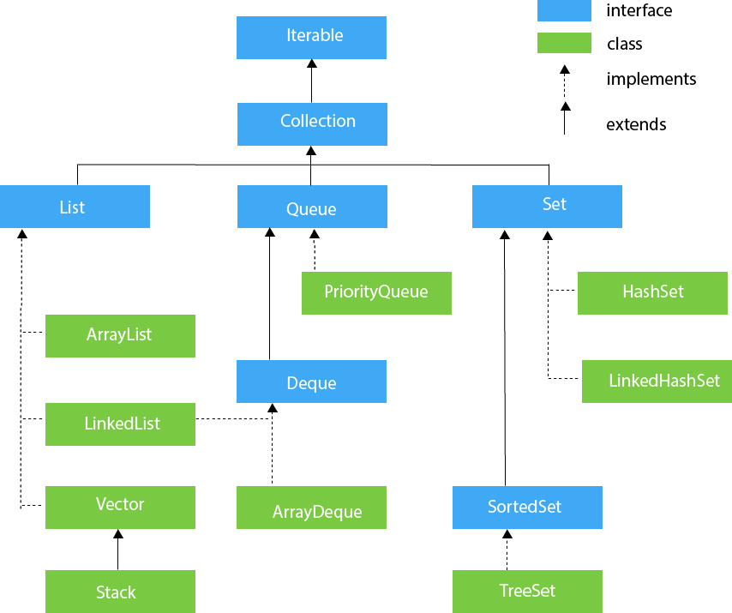
Methods of Collection interface
There are many methods declared in the Collection interface. They are as follows:
No. | Method | Description
1 | public boolean add(E e) | It is used to insert an element in this collection.
2 | public boolean addAll(Collection<? extends E> c) | It is used to insert the specified collection elements in the invoking collection.
3 | public boolean remove(Object element) | It is used to delete an element from the collection.
4 | public boolean removeAll(Collection<?> c) | It is used to delete all the elements of the specified collection from the invoking  collection.
5 | default boolean removeIf(Predicate<? super E> filter) | It is used to delete all the elements of the collection that satisfy the specified  predicate.
6 | public boolean retainAll(Collection<?> c) | It is used to delete all the elements of invoking collection except the  specified collection.
7 | public int size() | It returns the total number of elements in the collection.
8 | public void clear() | It removes the total number of elements from the collection.
9 | public boolean contains(Object element) | It is used to search an element.
10 | public boolean containsAll(Collection<?> c) | It is used to search the specified collection in the collection.
11 | public Iterator iterator() | It returns an iterator.
12 | public Object[] toArray() | It converts collection into array.
13 | public <T> T[] toArray(T[] a) | It converts collection into array. Here, the runtime type of the  returned array is that of the specified array.
14 | public boolean isEmpty() | It checks if collection is empty.
15 | default Stream<E> parallelStream() | It returns a possibly parallel Stream with the collection as its source.
16 | default Stream<E> stream() | It returns a sequential Stream with the collection as its source.
17 | default Spliterator<E> spliterator() | It generates a Spliterator over the specified elements in the collection.
18 | public boolean equals(Object element) | It matches two collections.
19 | public int hashCode() | It returns the hash code number of the collection.

Iterator interface
Iterator interface provides the facility of iterating the elements in a forward direction only.

Methods of Iterator interface
There are only three methods in the Iterator interface. They are:
No. | Method | Description
1 | public boolean hasNext() | It returns true if the iterator has more elements otherwise it returns false.
2 | public Object next() | It returns the element and moves the cursor pointer to the next element.
3 | public void remove() | It removes the last elements returned by the iterator. It is less used.

Iterable Interface
The Iterable interface is the root interface for all the collection classes. The Collection interface extends the Iterable interface and therefore all the subclasses of Collection interface also implement the Iterable interface.

MAP
A map contains values on the basis of key, i.e. key and value pair. Each key and value pair is known as an entry. A Map contains unique keys.
A Map is useful if you have to search, update or delete elements on the basis of a key.

Java Map Hierarchy
There are two interfaces for implementing Map in java: Map and SortedMap, and three classes: HashMap, LinkedHashMap, and TreeMap. The hierarchy of Java Map is given below:
A Map doesn't allow duplicate keys, but you can have duplicate values. HashMap and LinkedHashMap allow null keys and values, but TreeMap doesn't allow any null key or value.

Class | Description
HashMap | HashMap is the implementation of Map, but it doesn't maintain any order.
LinkedHashMap | LinkedHashMap is the implementation of Map. It inherits HashMap class. It maintains  insertion order.
TreeMap | TreeMap is the implementation of Map and SortedMap. It maintains ascending order.

Useful methods of Map interface
Method | Description
V put(Object key, Object value) | It is used to insert an entry in the map.
void putAll(Map map) | It is used to insert the specified map in the map.
V putIfAbsent(K key, V value) | It inserts the specified value with the specified key  in the map only if it is not already specified.
V remove(Object key) | It is used to delete an entry for the specified key.
boolean remove(Object key, Object value) | It removes the specified values with the associated  specified keys from the map.
Set keySet() | It returns the Set view containing all the keys.
Set<Map.Entry<K,V>> entrySet() | It returns the Set view containing all the keys and values.
void clear() | It is used to reset the map.
V compute(K key, BiFunction<? super K,? super V,? extends V> remappingFunction) | It is used to compute a mapping for the specified key and  its current mapped value (or null if there is no current  mapping).
V computeIfAbsent(K key, Function<? super K,? extends V> mappingFunction) | It is used to compute its value using the given mapping  function, if the specified key is not already associated with a value (or is mapped to null), and enters it into this map unless null.
V computeIfPresent(K key, BiFunction<? super K,? super V,? extends V> remappingFunction) | It is used to compute a new mapping given the key and  its current mapped value if the value for the specified  key is present and non-null.
boolean containsValue(Object value) | This method returns true if some value equal to the value exists within the map, else return false.
boolean containsKey(Object key) | This method returns true if some key equal to the key exists within the map, else return false.
boolean equals(Object o) | It is used to compare the specified Object with the Map.
void forEach(BiConsumer<? super K,? super V> action) | It performs the given action for each entry in the map until all entries have been processed or the action throws an exception.
V get(Object key) | This method returns the object that contains the value associated with the key.
V getOrDefault(Object key, V defaultValue) | It returns the value to which the specified key is mapped, or defaultValue if the map contains no mapping for the key.
int hashCode() | It returns the hash code value for the Map
boolean isEmpty() | This method returns true if the map is empty; returns false if it contains at least one key.
V merge(K key, V value, BiFunction<? super V,? super V,? extends V> remappingFunction) | If the specified key is not already associated with a value or is associated with null, associates it with the given non-null value.
V replace(K key, V value) | It replaces the specified value for a specified key.
boolean replace(K key, V oldValue, V newValue) | It replaces the old value with the new value for a specified key.
void replaceAll(BiFunction<? super K,? super V,? extends V> function) | It replaces each entry's value with the result of invoking the given function on that entry until all entries have been processed or the function throws an exception.
Collection values() | It returns a collection view of the values contained in the map.
int size() | This method returns the number of entries in the map.

Map.Entry Interface
Entry is the subinterface of Map. So we will be accessed it by Map.Entry name. It returns a collection-view of the map, whose elements are of this class. It provides methods to get key and value.
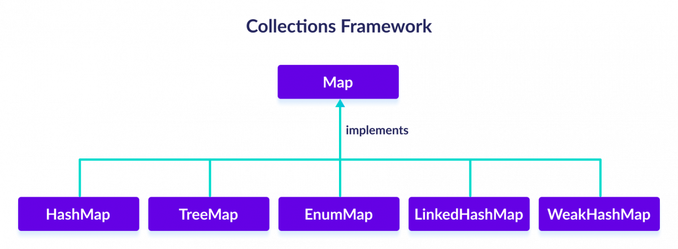

HasMap Syntax:

HashMap Object value(hm) =new HashMap();

Treemap Syntax:

TreeMap object value(tp) =new TreeMap(); //Creating hasmap to other Map

Linkedmap: Syntax

LinkedMap objectvlaue(lm)=new LinkedMap();

Constructor

A block of code that initializes (constructs) the state and value during object creation. It is called every time an object with the help of a new () keyword is created. Even if you haven't specified any constructor in the code, the Java compiler calls a default constructor.
Java constructors or constructors in Java is a terminology used to construct something in our programs. A constructor in Java is a special method that is used to initialize objects. The constructor is called when an object of a class is created. It can be used to set initial values for object attributes.

What are Constructors in Java?
In Java, a Constructor is a block of codes similar to the method. It is called when an instance of the class is created. At the time of calling the constructor, memory for the object is allocated in the memory. It is a special type of method that is used to initialize the object. Every time an object is created using the new() keyword, at least one constructor is called.

Constructor Types:
1.Default Constructor :
The default constructor is used to provide the default values to the object like 0, null, etc., depending on the type.
No-Argument Constructor

Parameterized Constructor:
we have created the constructor of Student class that have two parameters. We can have any number of parameters in the constructor.

Overloading Constructor:
In Java, a constructor is just like a method but without return type. It can also be overloaded like Java methods.
Constructor overloading in Java is a technique of having more than one constructor with different parameter lists. They are arranged in a way that each constructor performs a different task. They are differentiated by the compiler by the number of parameters in the list and their types.
Exception Handling

The Exception Handling in Java is one of the powerful mechanism to handle the runtime errors so that the normal flow of the application can be maintained.
In this tutorial, we will learn about Java exceptions, it's types, and the difference between checked and unchecked exceptions.
Dictionary Meaning: Exception is an abnormal condition.
In Java, an exception is an event that disrupts the normal flow of the program. It is an object which is thrown at runtime.
Exception Handling is a mechanism to handle runtime errors such as ClassNotFoundException, IOException, SQLException, RemoteException, etc.

Advantage of Exception Handling
The core advantage of exception handling is to maintain the normal flow of the application. An exception normally disrupts the normal flow of the application; that is why we need to handle exceptions. Let's consider a scenario:
- statement 1;
- statement 2;
- statement 3;
- statement 4;
- statement 5;//exception occurs
- statement 6;
- statement 7;
- statement 8;
- statement 9;
- statement 10;

Suppose there are 10 statements in a Java program and an exception occurs at statement 5; the rest of the code will not be executed, i.e., statements 6 to 10 will not be executed. However, when we perform exception handling, the rest of the statements will be executed. That is why we use exception handling in Java.

Hierarchy of Java Exception classes
The java.lang.Throwable class is the root class of Java Exception hierarchy inherited by two subclasses: Exception and Error. The hierarchy of Java Exception classes is given below:
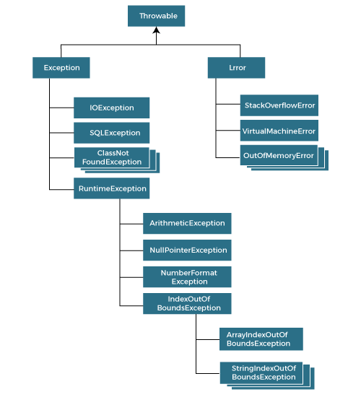

Types of Java Exceptions
There are mainly two types of exceptions: checked and unchecked. An error is considered as the unchecked exception. However, according to Oracle, there are three types of exceptions namely:
- Checked Exception
- Unchecked Exception
- Error
Checked Exception:
The classes that directly inherit the Throwable class except Runtime Exception and Error are known as checked exceptions. For example, IOException, SQLException, etc. Checked exceptions are checked at compile-time.

Unchecked Exception:
The classes that inherit the RuntimeException are known as unchecked exceptions. For example, ArithmeticException, NullPointerException, ArrayIndexOutOfBoundsException, etc. Unchecked exceptions are not checked at compile-time, but they are checked at runtime.
Error
Error is irrecoverable. Some example of errors are OutOfMemoryError, VirtualMachineError, AssertionError etc.
Java Exception Keywords
Java provides five keywords that are used to handle the exception. The following table describes each.
Keyword | Description
try | The "try" keyword is used to specify a block where we should place an exception code. It means we  can't use try block alone. The try block must be followed by either catch or finally.
catch | The "catch" block is used to handle the exception. It must be preceded by try block which means we  can't use catch block alone. It can be followed by finally block later.
finally | The "finally" block is used to execute the necessary code of the program. It is executed whether an  exception is handled or not.
throw | The "throw" keyword is used to throw an exception. Syntax: throw new exception_class(“error message)
throws | The "throws" keyword is used to declare exceptions. It specifies that there may occur an  exception in the method. It doesn't throw an exception. It is always used with method signature.

